

**Dynamic Intelligent Q/A System**

**PROJECT INCREMENT 1 REPORT**

**SUMMER 2017**

**Team – 3  
 Nageswara, Rao Nandigam – 18  
 Chakilam, Revanth – 2**

**Syed, Moin – 28**

**Sankar, Pentyala – 22**

Motivation:

We the Team Innovators 2.0 are in a search of data and knowledge. But Importantly we have a lot of difference between information, data, statistics and knowledge. When we speak about Information intruding and a semantic google search is more improvised and we can retrieve relevant information sitting in home. “Question Answering” is a dynamic way of retrieving Information, which learns knowledge. The main focus is particular in obtaining the respective documents but also particular in obtaining the respective response to query we post. Question and Answer system is capable of performing the NLP Processing, Information gathering, topic discovery, Machine Learning and Sematic Search. Question and answer system itself is the beauty of NLP and same instance have a bit of science in its essence. Question and Answer System is required every aspect, let be in the field of health and sciences, an intelligent learned system for children at schools, professional assistant etc. So, this is necessary in each case when we require some help from computer as well. It goes without saying that it is worth exploring the exciting field of question answering.

Objective:

Our Project critically deals with the building of typical model of information knowledge retrieval, named Question & Answering model. If suppose any given query asked in natural human language, Our question and answer system is implemented in such a way to extract the reality possible answer in the form of a pre-defined named-entity type, that is a human person, or may be an organization, a location, etc. Thus, we are connecting the question objects with live entities in a given radius is important in question and answer system. The projects main motto is to enhance the performance of the Question Answering system by using the knowledge and data from the natural grouping of word in the document files.

Significance:

We are constructing a knowledge graph such a way to build the question and answering system to deliver answers very effectively. To give better the results from the system designed we are applying different techniques such as NLP operations, Information retrieval, topic discovery and knowledge discovery.

Q/A System:

For this project, we have taken the Data set from BBC sports concentrating on the sport Cricket. From this Data set we try to construct knowledge graph and making system dynamic to answer all possible questions on sports questions.

Datasets:

BBC Sports domain

<http://mlg.ucd.ie/datasets/bbc.html>

Design:

Workflow:

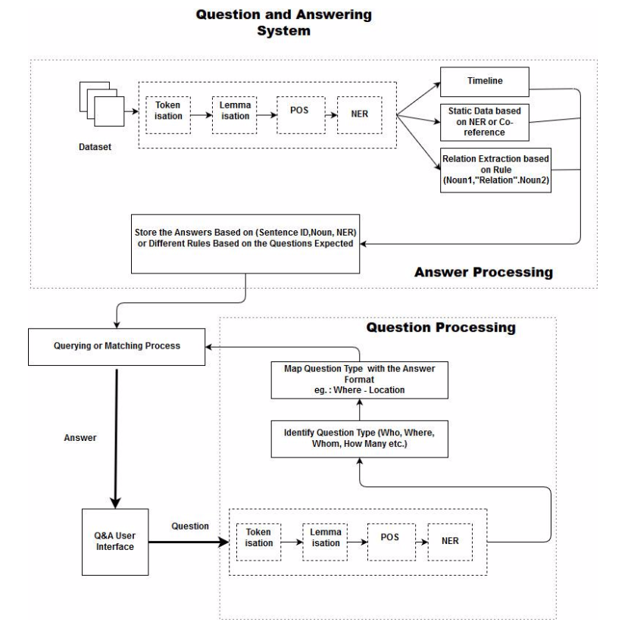

Knowledge Graph:

<Won>

<Scored>

<Has_Name>

<Sets_up>

<Has name>

<hits >

<Named>

<Has >

<Named>

<Named>

<Named>

<took >

<Scored >

<Scored >

Implementation:

NLP Process:

1. Doing NLP processing of tokenizing, lemmatization and extracting named entity relations and storing it in HashMap.

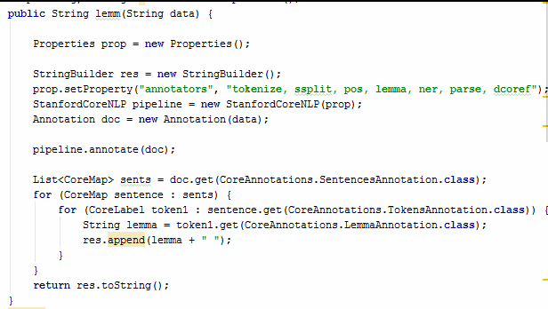

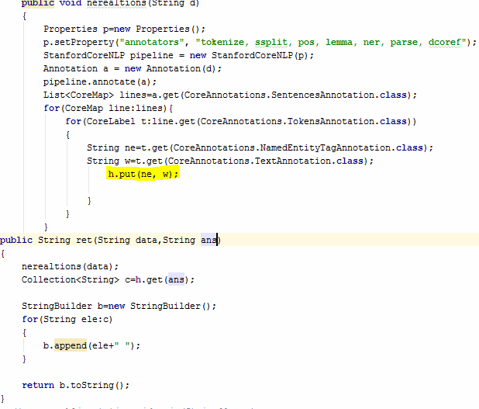

Asking questions and finding answer type based on “wh” words

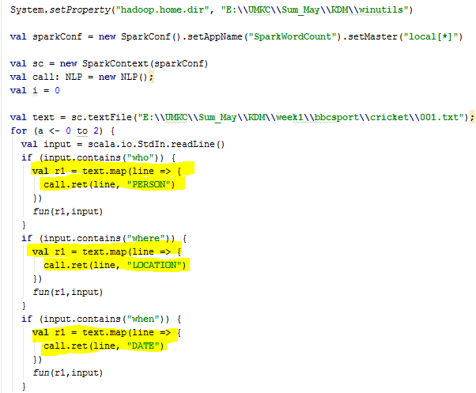

And based on answer type, we are calling particular document who is responsible to answer.

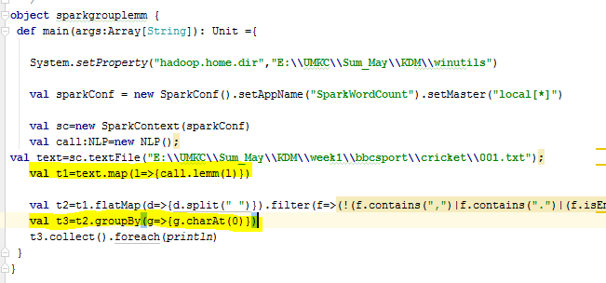

Question and answers:

Question 1:

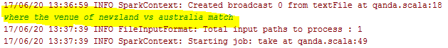

Answer:

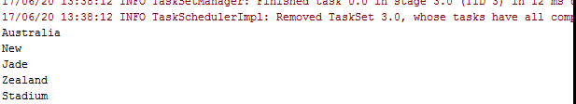

Question 2:



Answer:

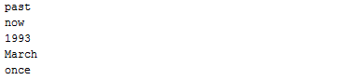

Question 3:



Answer:



Project Management:

Contribution:

GitHub screens:

Board:

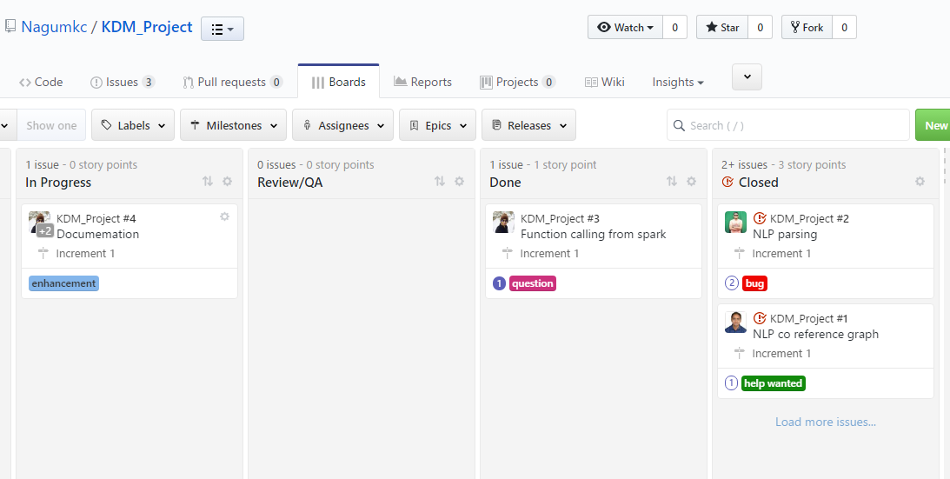

Burndown report:

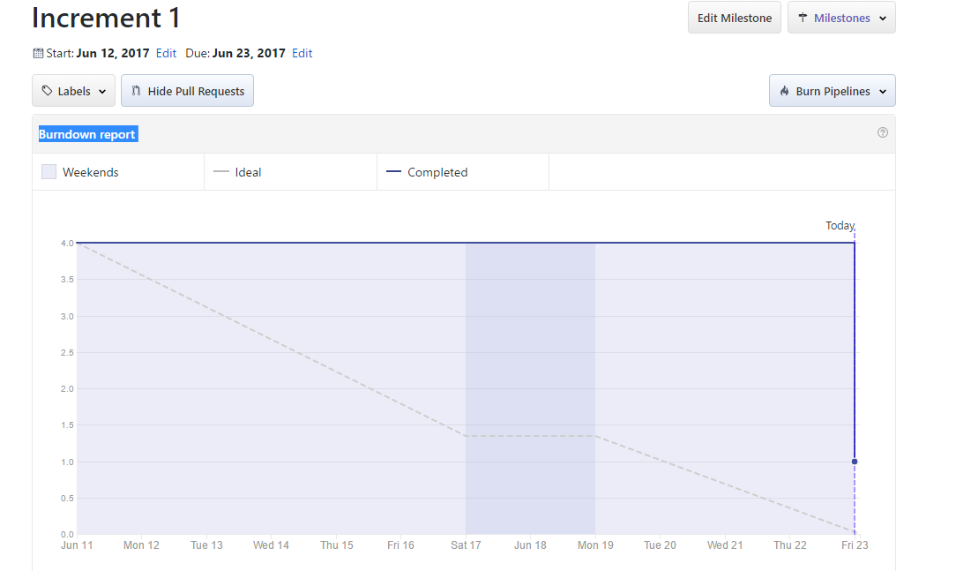

Issues:

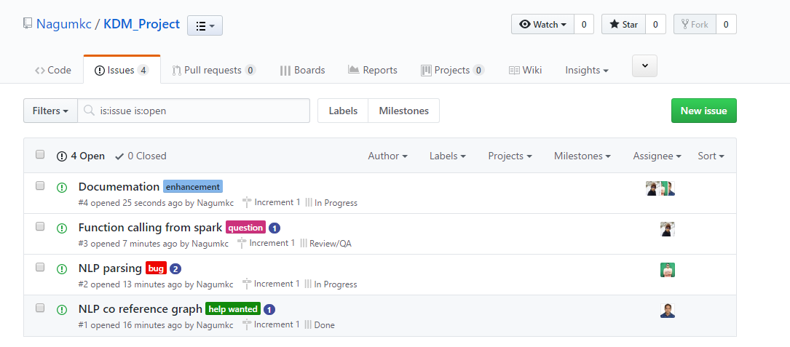

Future work:

Till now, we have extracted the data statically from the Data set using the NLP techniques and have created question and answering system based on the extracted data.

The Future scope is to generate the Question and Answering based on the Knowledge graph dynamically by parsing data and finding out the entities and relationship between the entities. The main Entity extraction information is implicitly done using Natural language and explicitly done using structured data markup.